MINI PROJECT REPORT

REAL ESTATE PRICE PREDICTION



NNN

Submitted By:

1)Name: RAMANSH SANGAL
University Roll Number:1803210120
2)Name: NIHARIKA GORAIN
University Roll Number:1803210104

SUBMITTED TO:

Department of Computer Science & Engineering
ABES engineering college
GHAZIABAD

DECLARATION

I hereby declare that the Report entitled “REAL ESTATE PRICE PREDICTION” is an authentic record of my own work as requirements of Mini Project during the period from 01/06/2020 to 01/08/2020 for the award of degree of B.Tech. (Computer Science & Engineering), ABES Engineering College, Ghaziabad.

Signature: Signature:

Name: Ramansh Sangal Name: Niharika Gorain
Roll Number: 1803210120 Roll Number: 1803210104

Date: 20/11/2020

TABLE OF CONTENTS

Page No.

COVER PAGE i
DECLARATION ii
TABLE OF CONTENTS iii
CHAPTER 1 INTRODUCTION iv
1.1 AIM OF THE PROJECT iv
1.2 OBJECTIVE OF THE PROJECT iv
1.3 SCOPE OF THE PROJECT iv
CHAPTER 2 SURVEY v
CHAPTER 3 TOOLS AND TECHNOLOGY USED vi
3.1 MACHINE LEARNING vi
3.2 SOFTWARE vi
3.3 PACKAGES USED vii
CHAPTER 4 SNAPSHOTS viii
4.1 PACKAGES USED viii
4.2 DATASET FROM KAGGLE ix
4.3 ANALYZING DATASET ix
4.4 DATA CLEANING x-xi
4.5 DATA PREPROCESSING xii
4.6 DATA VISUALIZATION xiii-xiv
4.7 MODEL BUILDING xv-xviii
CHAPTER 5 RESULTS AND DISCUSSIONS xix-xx
CHAPTER 6 CONCLUSIONS AND FUTURE WORK xxi
CHAPTER 7 REFERENCES xxii

CHAPTER 1

INTRODUCTION

  - Aim of the Project:
The aim of this project is that it will predict the real estate prices based on the data which we are using in our project.

  - Objective of the Project:
The main objectives of this project are to create a regression model that is able to accurately estimate the price of the house.
We will take house location, total square feet area, number of bathrooms and BHK size from the user and we will provide them with the per square feet price.

  - Scope of the Project:
Housing prices are an important reflection of the economy, and housing price ranges are of great interest for both buyers and sellers. In this project, house prices will be predicted given explanatory variables that cover many aspects of residential houses.

CHAPTER 2

SURVEY

We surveyed and got this idea of real estate price prediction from websites like “Magic Bricks” and “Zillow”. The later one has a feature called zestimator. Zestimator predicts the price of real estate based on sqft area, bathrooms, bedrooms etc. Our project is basically based on this feature which seems to be helpful for those people who are in search of a house or any real estate and they can spend up to a certain budget. It will help them find a suitable property under their budget.

CHAPTER 3

TOOLS AND TECHNOLOGY USED

Details about the technology and built-in packages we are using in this particular project:

3.1)MACHINE LEARNING: It is an application of Artificial Intelligence (AI) that provides systems the ability to automatically learn and improve from experience without being explicitly programmed. The process of learning begins with observations of data such as examples, direct experience in order to look for patterns in data and make better decisions in the future based on the examples that we provide. The primary aim is to allow the computers learn automatically without human intervention.

3.2)SOFTWARE: The software which we are using is Anaconda Navigator. It is a desktop GUI included in Anaconda distribution that allows you to launch applications and easily manage conda packages, environments, and channels without using command-line commands. Via Anaconda, we use Jupyter Notebook. It is an open source web-based application which allows you to create and share documents that contain live code, equations, visualizations and narrative text.

3.3)PACKAGES USED:
- Pandas
- Numpy
- Seaborn
- Matplotlib
- SkLearn
- Linear Regression
- Train_test_split
- Cross_val_score
- Shuffle Split
- Lasso
- GridSearchCV
- DecisionTreeRegressor

CHAPTER 4

SNAPSHOTS
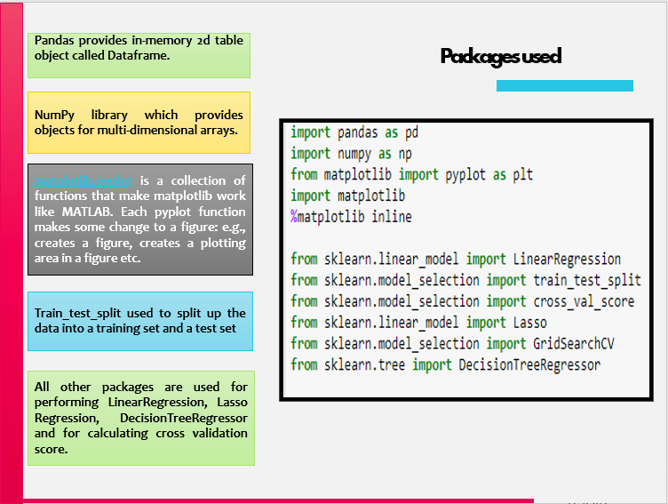
(4.1) Packages Used

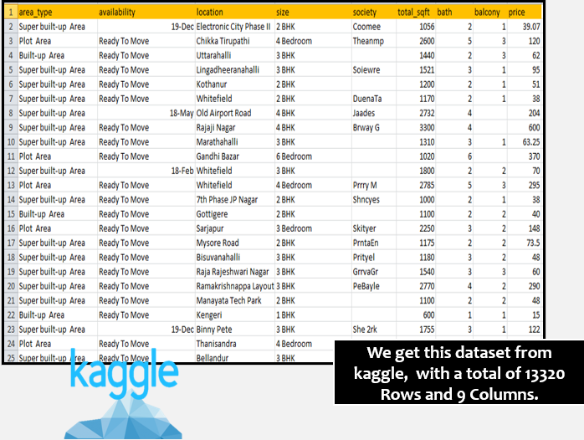(4.2) Dataset from Kaggle

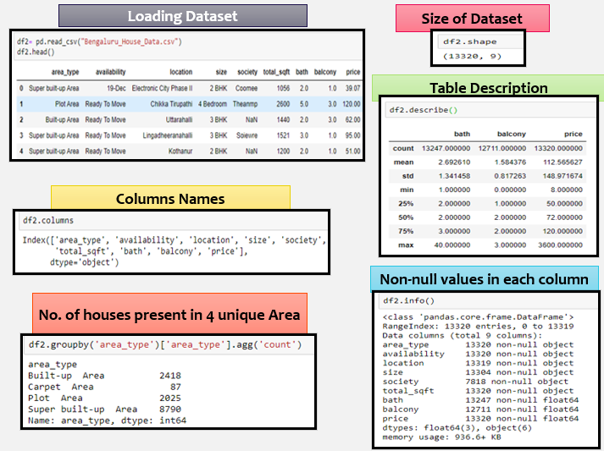
(4.3) Loading and analyzing dataset

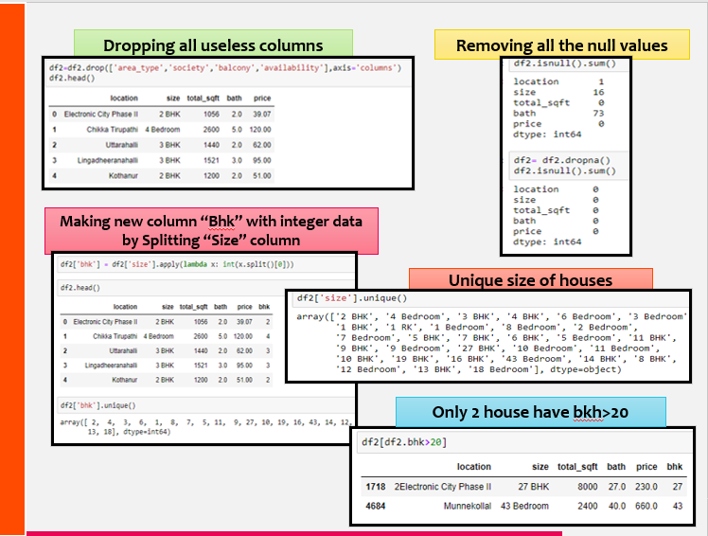
(4.4)DataCleaning
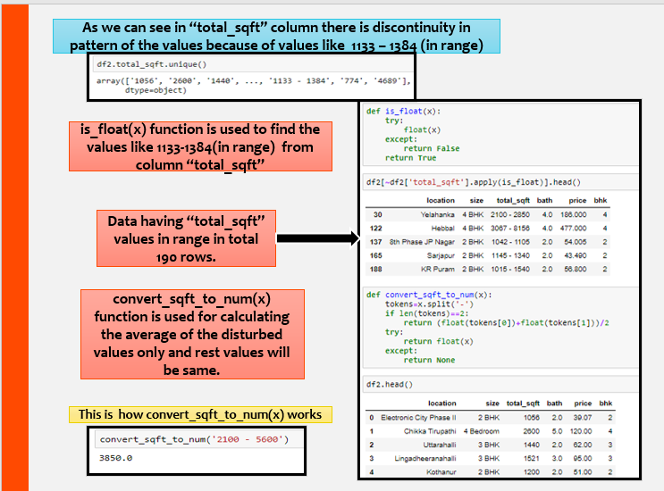
(4.4.1)
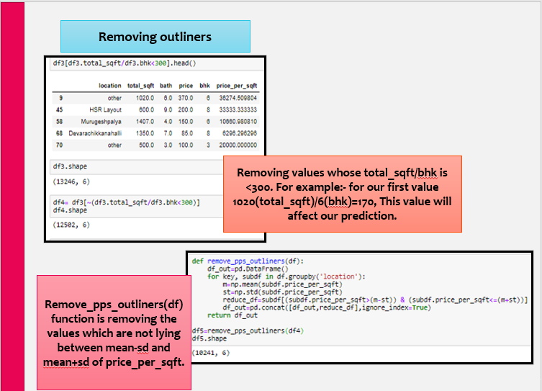
(4.4.2)

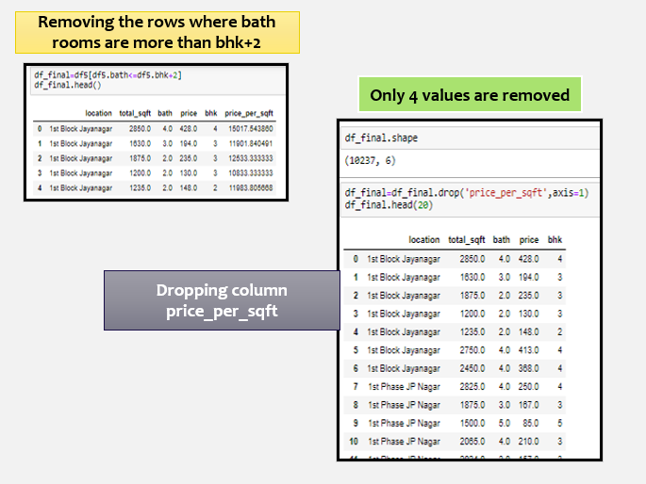
(4.4.3)
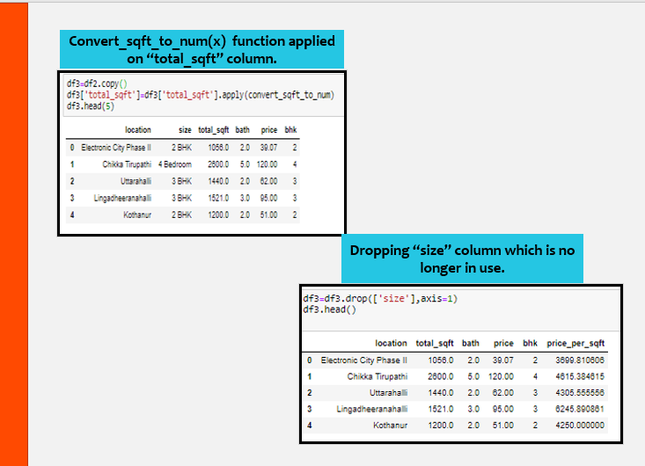
(4.5) Data Preprocessing
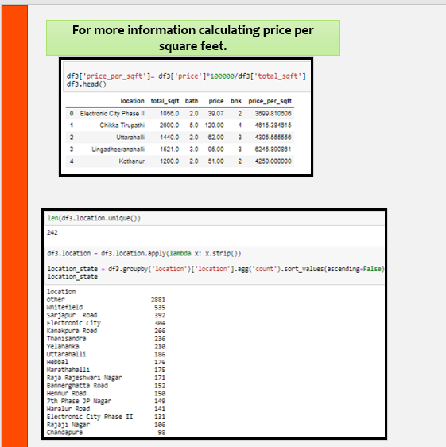
(4.5.1)

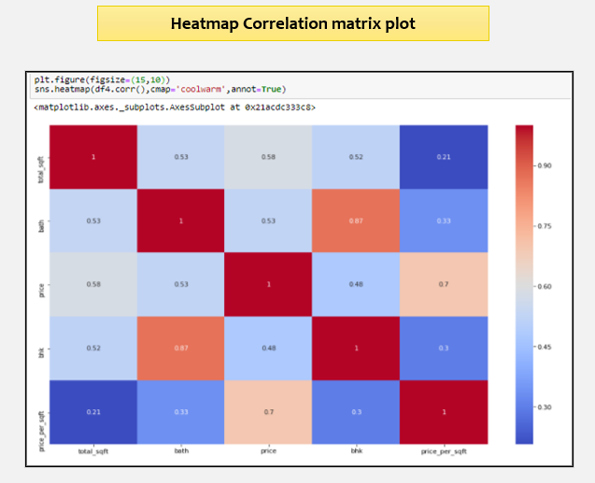
(4.6) Data Visualization
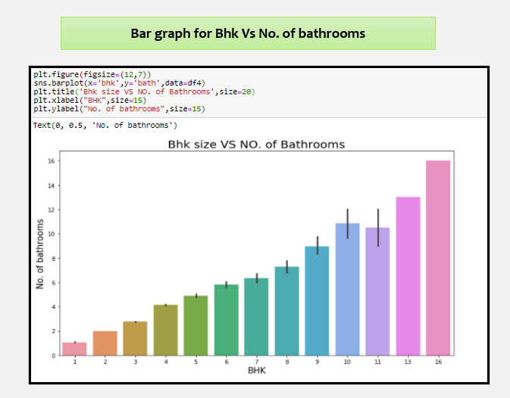
(4.6.1)

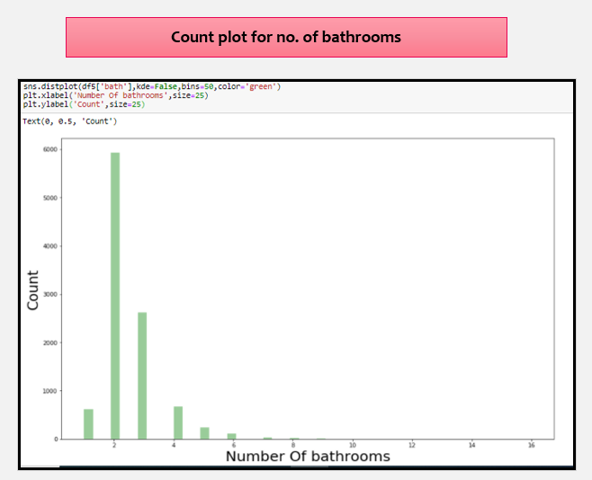
(4.6.2)

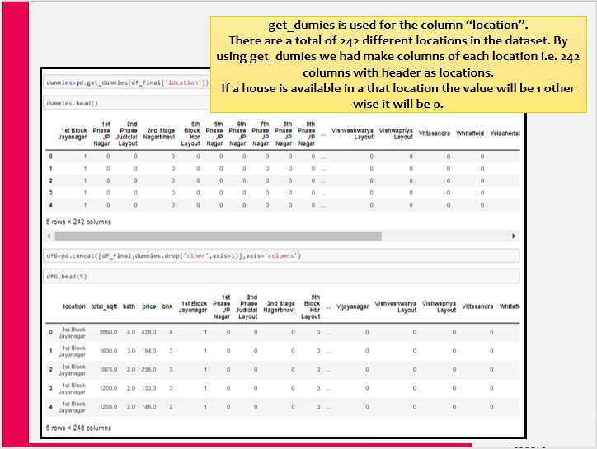
(4.7) Model building
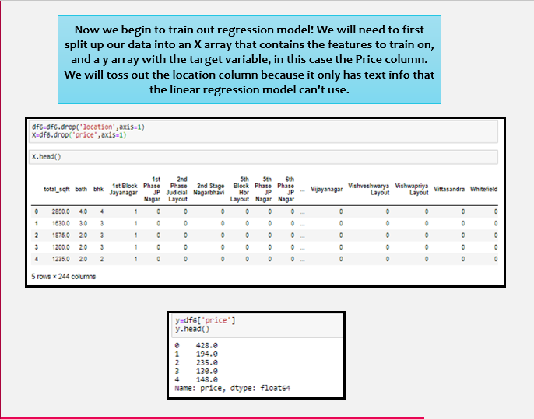
(4.7.1)

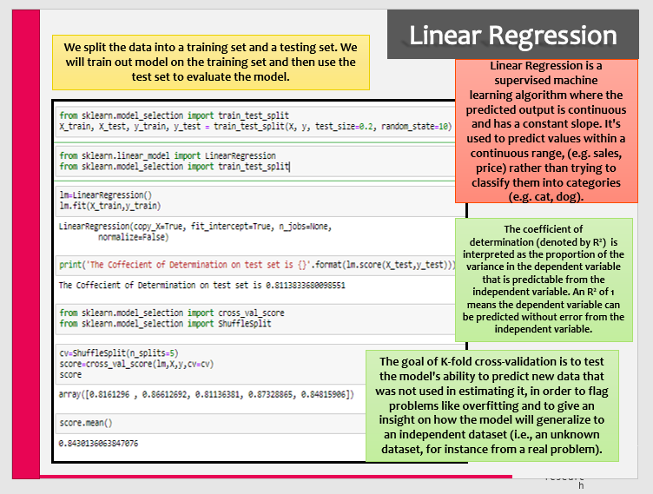
(4.7.2) Linear Regression

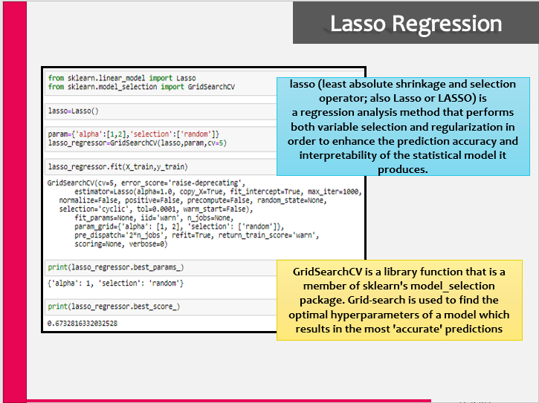
(4.7.3) Lasso Regression

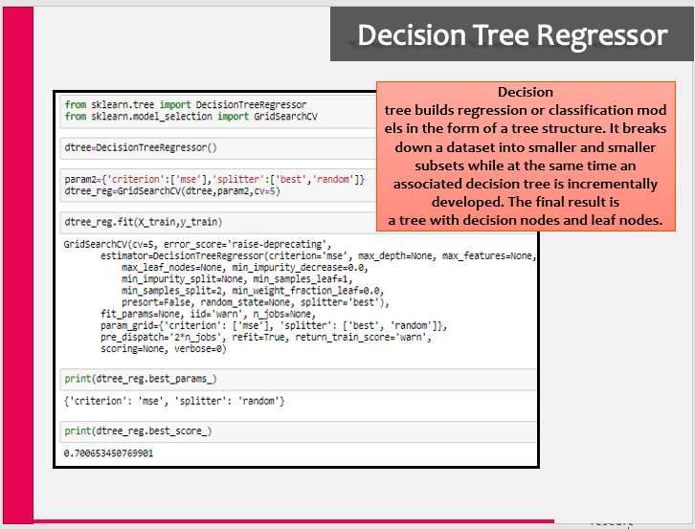
(4.7.4) Decision Tree Regressor
CHAPTER 5
RESULTS AND DISCUSSIONS

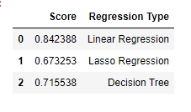
(5.1)
The above image shows the best scores for the three ML algorithms that we used. It clearly shows that the Linear Regression achieves the highest score and hence will be used in our model for predicting prices.
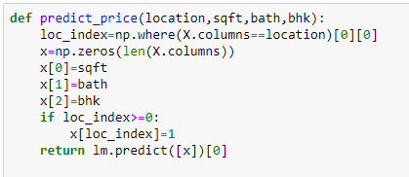
(5.2)
Here, we have created a price predicting function that finally predicts the price of a property according to the user inputs. The user will input location, square feet, bathrooms and bhk and will get the results. Here you can see we are using ‘lm.predict’ for our model which denotes linear regression as mentioned above.
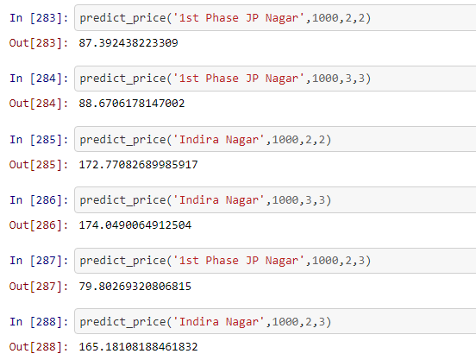
(5.3)
Here are some of the results from the function that we made for predicting prices.Our model is giving almost 84% accuracy. As you can see from the first and second example, for same location, same sqft area, but one extra bathroom bhk, the price increased. Also from fourth and sixth example, we can see that the price decreased for one less bathroom but the location, sqft area and bhk are same.
CHAPTER 6
CONCLUSIONS AND FUTURE SCOPE

It was a wonderful and learning experience for us while working on this project and utilizing our time during the lockdown period. This project took us through the various phases of project development and gave us real insight into the world of real estate.We enjoyed each and every bit of work we had put into this project. The conclusion on Overall, the project has achieved its objectives.

The Future Scope is to add User Interface to the project so that it will become more interactive for the user. The user interface (UI) is the point at which human users interact with a computer, website or application. The goal of effective UI is to make the user's experience easy and intuitive, requiring minimum effort on the user's part to receive maximum desired outcome.
CHAPTER 7
REFERENCES
- https://www.youtube.com
- https://udemy.com/(Python for machine learning and data science bootcamp)

